Peer review of journal
Name
Institution affiliation
Course name
Instructor
Date

Article naming
Article title: Phylogeography, genetic diversity, and population structure of Nile crocodile populations at the fringes of the southern African distribution.
The title of the article shows that the authors will explore three things; phylogeography, genetic diversity and population structure of Nile Crocodile populations. The title of the article also introduces us to the setting of the research. In other words, where the research will be carried out. In this case the setting is at the fringes of the southern African distribution (Africa). Therefore, from the title we learn that the study is to done in Sub-Saharan Africa and not anywhere else. African countries where the study was done include South Africa, Namibia, Botswana, and Malawi. The first aspect of the study (phylogeography) refers to the study of past developments that are responsible for the older and present-day geographic distributions of certain species. The second aspect of the study which is genetic diversity refers to the total number of genetic features in the genetic makeup of species. Genetic diversity includes ways in which populations adapt to the ever changing environments and ranges from the number of species to differences within species. The last aspect is population structure which includes processes like mutation, natural selection, demographic history, and genetic drift. All these aspects are covered in the study.
Additionally, from the title, we see the subject of the study to be Nile crocodiles. Since the Nile crocodiles are only found in Africa and mainly sub-Saharan Africa, we expect the setting to be in Africa, which is the case.
The article was authored by Barbara van Asch, William F. Versfeld, Kelvin L. Hull, Alison J. Leslie, Timoteus I. Matheus, Petrus C. Beytell, Pierre du Preez, Ruhan Slabbert, and Clint Rhode. The article was published in December 23, 2019. The authors did not have conflict of interests and took various roles in the study. These authors are qualified for this research because they have mastered in genetics, phylogenetics and phylogeography.
- Subject Being Studied
Crocodiles are aquatic and carnivorous reptiles living in the tropical and subtropical freshwater basins like rivers, lakes, brackish, and wetlands. In Africa, there are three main groups of crocodiles: dwarf crocodile (Osteolaemus tetraspis), slender-snouted crocodile (Mecistops cataphractus), and Nile crocodile. Geographically, Nile crocodile can be found at the Northern section of River Nile, westerns sections of Senegal river to the Congo basin, in lakes along the Great Rift valley to the east of Africa, along rivers Kunene in Namibia, Okavango Delta in Botswana, and along St. Lucia wetlands in South Africa and Madagascar. Reports by Crocodile Specialist Group shows that the total population of Nile crocodile ranges between 250,000 and 500,000. As per the IUCN Red List of Threatened Species, the Nile crocodile is classified as a “Low risk/Least Concern.” However, Countries are classifying their Nile crocodile populations independently depending on the population of crocodiles in their regions. Namibia has classified the Nile crocodiles as "Peripherally endangered," while South Africa classified its Nile crocodiles as "vulnerable," hence imposing legal acts to protect them from extinction.
The recent genetic studies have shown a complex evolutionary history phylogeographic divergence between Nile crocodiles in different regions. For a broad picture of Nile crocodile, the establishment of phylogeographic patterns helped to recognize two species, including Crocodylus niloticus and Crocodylus suchus. After that, there was the structuring of their population based on their geographic distribution. The earlier studies never provided fine details on the Nile crocodile distribution in Southern Africa, which enabled this study to be major on the geographic distribution in regions south of Africa. The study majored on wild and captive crocodile populations across major regions comprising of Okavango, Limpopo, Lower Kunene, and Lower Shire river basins without forgetting the KwaZulu-Natal region. The researchers used the multi-marker strategy that helped give phylogeographic and genetic diversity patterns. This included the panel of 11 nuclear microsatellites and mitochondrial data. The study shows that the distribution of mitochondrial haplotypes was due to the ancestral genetic interaction present in the entire southern region, considering a loss of diversity in the North-south axis. However, due to the genetic variation subdivision being based on the population’s regions, getting data of the wild population, there was the likelihood of compromising by raising conservation concerns.
- Method Used
Collecting of Samples and Extracting DNA Samples
There was a collection of 149 Nile crocodile samples from wild populations in the Okavango river, Lower Shire river, and Lower Kunene river systems. From the Okavango river system, 62 samples, Lower Kunene river system, 12 samples, and lower Shire river 52 samples. On the Okavango river system, there were three sampling sites, namely Okavango delta in Botswana with 29 samples, Otjiwarongo crocodile ranch in Namibia with 13 samples, and Bwabwata national park in Namibia with 20 samples. The Lower Shire river system in Malawi had two sampling sites: northwards to Kapichira Falls with 27 samples and the other south of the Zambezi confluence with 25 samples. Additionally, the wild-caught population kept in commercial crocodile farms assumed to originate from Limpopo river with 13 samples and the coastal estuarine of KwaZulu Natal in South Africa with 13 samples. The regions are clearly described in figure (F1) below.
Figure (F1)
The researchers extracted blood samples from the ventral caudal tail vein. They stored the samples in K2EDTA vacutubes. However, they removed tissue samples of one to two scutes, following a unique pattern that would help to identify individual crocodiles in the future. They stored the samples at -20⁰c until DNA extraction was done. The DNA extraction process was done using a CTAB protocol, after which they were stored at the same temperature as the samples.
Mitochondrial diversity, population structure, and phylogenetic reconstruction
The researchers used the Arlequin software to estimate each population's standard diversity measures. The diversity measures comprised of the number of nucleotide diversity, the average number of pairwise nucleotide differences, the number of haplotype diversity, and the haplotype. They developed a median-joined network that illustrates the evolutionary connections existing between the haplotypes by use of the Network but under default settings.
Measurement of Nuclear diversity and population structure
GenAlEx v6.5 was used in the calculation of fixation index (F_{is}), observed heterozygosity (H_{O}), number of alleles (A_{n}), expected (H_{e}), and departures from Hardy-Weinberg equilibrium (HWE). Additionally, there was the estimation of Rarefied allelic richness (R_{s}) by use of HP-RARE v1.1. And the calculation of a locus-by-locus hierarchical AMOVA and Pairwise F_{st} using the GenAlEx v.6.5. However, for the AMOVA, samples had to be grouped in five different regions, which are based on geographic areas, including the KwaZulu-Natal in South Africa, Lower Kunene in Namibia, Okavango in Namibia and Botswana, and Lower Shire in Malawi. The researchers performed the Principal coordinate analysis (PCoA) by use of GenAlEx v.6.5, considering the genetic distance using the variance standardization. There was an inference of the ancestral population by use of STRUCTURE v2.3.4, and the initial analysis on the dataset was applied for all K-values ranging between 1 and 16.
Effective estimations of population size and bottleneck
There was a contemporary estimation of population sizes by use of the linkage disequilibrium method or LD approach. The approach was using the assumptions of a random mating model for all the populations inferred in the STRUCTURE analysis. The procedure was executed in NeEstimator v2.01. The execution of recent bottlenecks expansion by use of Wilcoxon signed-rank test is a vital deviation as a result of heterozygosity excess following the Stepwise Mutation Model (SMM) and the Infinite Allele Model. However, 1000 replications were used to perform the bottleneck analyses and inspection of allele frequency distributions.
Estimation of the magnitude of populations and directionality
Researchers applied the Program Migrate-N to determine the wild populations' interaction in the river systems. In the process, there was the investigation of the population's migration patterns between the Okavango (OR) and Shire (SH). There was the testing of two models for the two river systems. First, a model comprising of the distinct population showing migrations to and from each population, and secondly, a model with assumptions of a complete panmixia ranging between the populations. Looking into the OR, there were two additional models which were evaluated. The model assumed migration of population to Namibia from Botswana and another model assuming population migration from Namibia to Botswana. On the other hand, for the SH, there was an unequal gene flow identified to exist between Northern and the southern Shire, but on the contrary, there was another migration from southern to the northern Shire.
- Results
Figure (F2) below shows that Nile crocodiles from Namibia, South Africa, Botswana, and Malawi include Crocodylus suchus species. There are only five haplotypes of Nile crocodiles found in these regions along with the Southern African river systems. The haplotypes were realized to be among the seven variable sites, and incidentally, the sites consisted of transitions. It was notable that all individuals from the Okavango river systems from which the researchers got 62 samples and Lower Kunene river systems from where 12 samples were got from had a similar haplotype (Hap 3). This was also common to the KwaZulu-Natal region of South Africa and Gabon. Nevertheless, there were 2 haplotypes got in the Lower Shire river system that had 52 samples. The two haplotypes comprised of Hap 10 from two samples and Hap 11 from two samples as well in the total dataset.
These two haplotypes were considered to be unique and were reported for the first time. The other 2 haplotypes were reported in South Africa and Madagascar, respectively, but incidentally, they were previously reported in Malawi, which had Hap 8 from 12 samples taken by the researchers. The remaining haplotype Hap 9 got from 10 samples on the total dataset, which South Africa, Zimbabwe, Madagascar, and Tanzania share. According to the results acquired, there were no haplotypes shared between the Lower Kunene/Okavango and Lower Shire that is between Botswana and Namibia. These results proved that the eastern African Nile crocodiles in the Limpopo, KwaZulu-Natal, and Lower Shire were considered to have very high haplotype diversity. KwaZulu-Natal was leading with the highest haplotype diversity, as shown on the table (T1) below.
F2
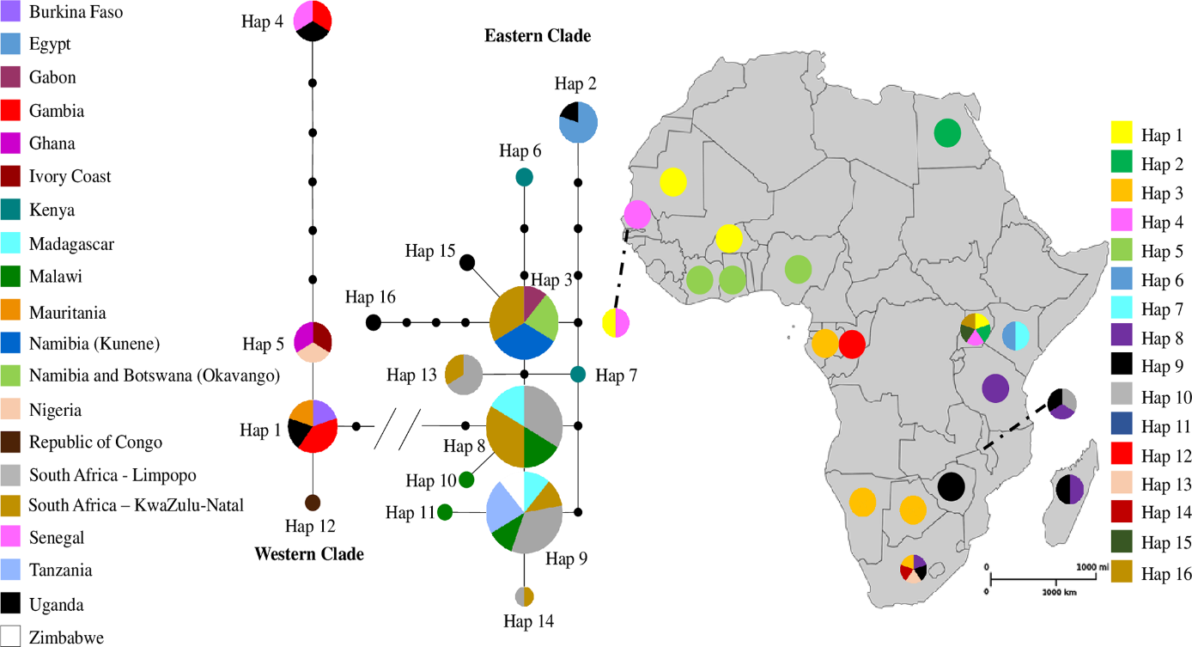
Table (T1). Standard genetic diversity measures of Nile crocodile in three river systems in southern Africa. N - number of individuals, H - number of haplotypes, h - haplotype diversity, π - nucleotide diversity, k - mean number of nucleotide differences between haplotypes.
River system | N | H | h | π | k
Lower Kunene River | 12 | 1 | 0 | 0 | 0
Okavango River | 52 | 1 | 0 | 0 | 0
Lower Shire River | 47 | 4 | 0.332 ± 0.083 | 0.015 ± 0.008 | 8.144
Limpopo River | 12 | 4 | 0.773 ± 0.069 | 0.005 ± 0.0009 | 2.591
KwaZulu-Natal | 9 | 5 | 0.861 ± 0.087 | 0.006 ± 0.0009 | 3.000
South Africa | 21 | 5 | 0.810 ± 0.042 | 0.006 ± 0.0005 | 2.752

- Analysis of the results
According to the table (T2) below, it is evident that the Lower Shire river system led with the highest diversity having H_{e}=0.67, H_{o}=0.62, and R_{s}=4.29. The average of the data was across the north and south samples. Then, South Africa followed with H_{e}=0.64, H_{o}=0.55, and R_{s}=3.78, which was also an average got from Limpopo all along to KwaZulu-Natal. Thirdly, the Okavango river system had H_{e}=0.61, H_{o}=0.59, and R_{s}=3.65 got from an average of all three groups and, Lower Kunene river system H_{e}=058, H_{o}=0.50, and R_{s}=3.31. However, fixation indices F_{is} was an indication of a Lower Kunene river having a slight excess of homozygotes (F_{is}=0.149) and South Africa (F_{is}=0.182). On the other hand, the Lower Shire river system with a fixation index of (F_{is}=0.149) and south (F_{is}=0.071) and the KwaZulu-Natal areas with (F_{is}=0.348).
Table(T2)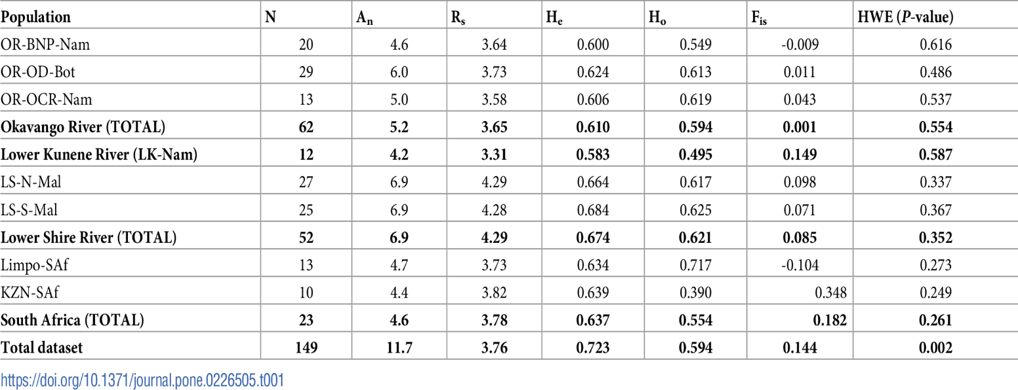
Based on ΔK, the number of population clusters was considered to be estimated at two, K=2. This was representing the eastern clusters comprising of Malawi and South Africa and western clusters comprising of Namibia and Botswana, all in the Southern part of Africa. However, the use of Bayesian statistics provides an estimated number of populations as five, K=5. At this point, all the river systems, which include the Lower Kunene river, Lower Shire river, Okavango river system, KwaZulu-Natal, and Limpopo, represent individual population clusters as demonstrated in the figure (F3).
Figure (F3)
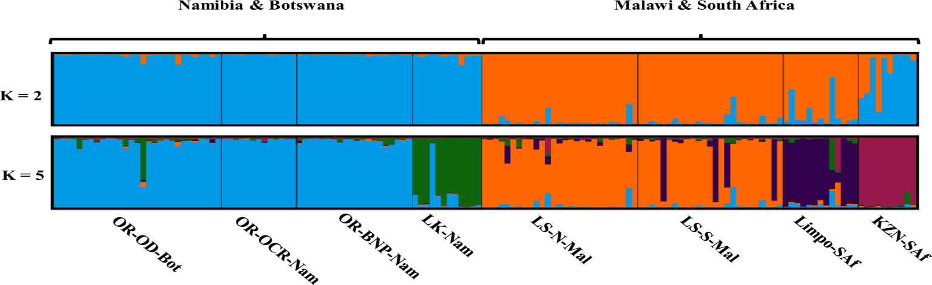
Looking at the PCoA, there is a primary population separation into western and eastern clusters. The western comprises Namibia and Botswana, while the eastern comprises Malawi and South Africa. The clustering was along the first coordinate that provided an explanation to 13.16% of the variation. The second coordinate gave an explanation of 8.34% of the variation that partitioned helped to divide the sampling populations more into clusters that have certain relationships with individual river systems. Moreover, there was more partitioning that AMOVA supported and was ascribed a substantial percentage of genetic variation of about 15% to differences among other regions of river systems. With these statistics below, the principal coordinate analysis (PCoA) shows the upper hierarchical population clusters of both the east and west. These are principally distinguished by the first coordinate.
Nevertheless, the secondary population cluster shows the regional river systems consisting of the Lower Kunene river, Lower Shire river, Okavango river system, KwaZulu-Natal, and Limpopo regions. The OR-BNP-Nam represents the Okavango river system through Bwabwata national park to Namibia, OR-OD-Bot representing the Okavango river system through Okavango delta to Botswana OR-OCR-Nam representing Okavango crocodile ranch through Okavango river to Namibia. Then, LK-Nam shows the Lower Kunene river to Namibia and Limpo-SAf representing the Limpopo river to South Africa, LS-S-Mal representing the Lower Shire River (south) Malawi, and KZN-SAf showing KwaZulu-Natal to South Africa. They can be got from the figure (F4) below.
Figure (F4)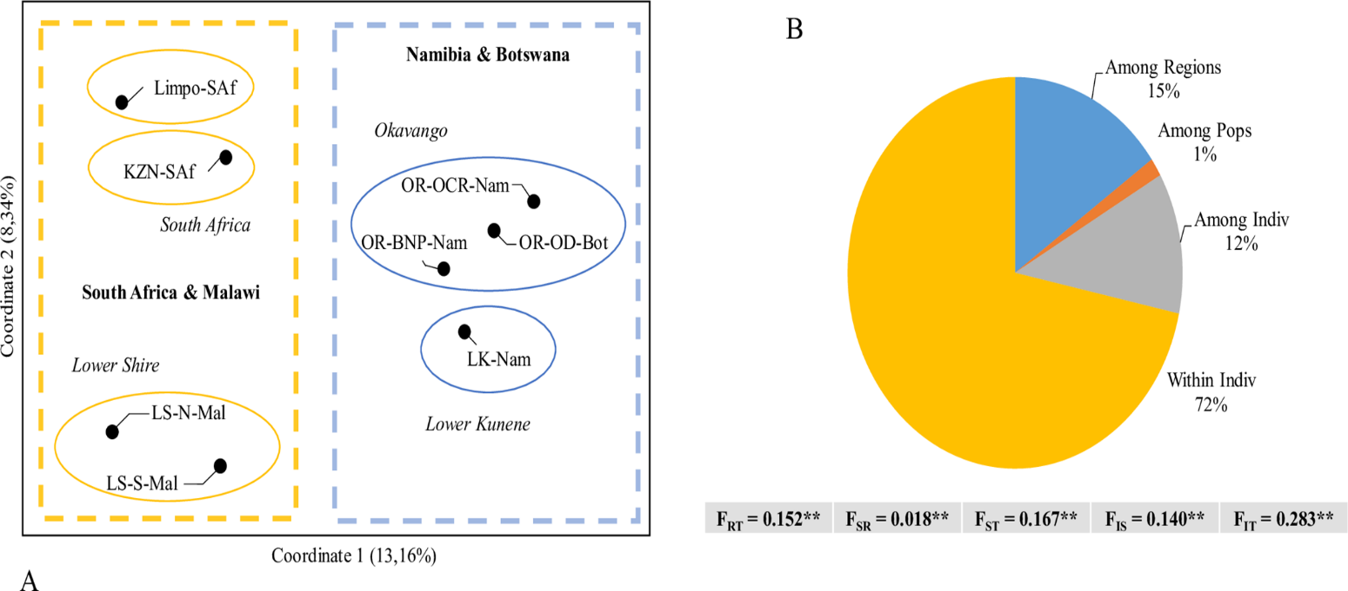
For effective analysis of the population size, growth, and contraction and looking into mean relatedness, researchers majored on checking and comparing the population sizes, which ranged from 115.9 to infinity, considering various clusters. The researchers pointed that, lower confidence bound for Limpopo, KwaZulu-Natal, and the Lower Kunene river, where some of the sampled populations were below the required absolute critical 50 value. On the other hand, the upper-bound estimate of the Okavango river was identified to be lower than 500. This was basically termed to be a genetically healthy, sustainable, and justifiable population. Also, for the Lower Shire river, there was a lower bound estimated to be lower than 500. Also, with an upper bound approximately standing at 868.1 as indicated on the table (T3) below.
Table (T3)
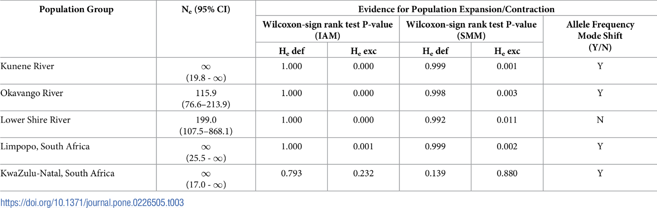
The study reports above on the genetic diversity and phylogeography of Nile crocodiles from regions south of Africa prove to be of great importance. It contributes much towards understanding the ancestral and today's Nile crocodile's history by investigating and exploring the novel genetic data of their distribution in Southern Africa.
Conclusion
The study was of great significant to the knowledge about crocodile distribution, conservation, and management in sub-Saharan Africa. It provides new insights to the geographical fringes of the distribution of C. niloticus. The study revealed that C. niloticus was found in the distribution of mitochondrial haplotypes. This means that there exists a variety of different ancestral populations in Sub-Saharan Africa. This has been brought about geographical changes in topology. There was moderate genetic diversity within populations in relation to other studies. One of the most significant findings from the study is that evidence of shrinking population of the species with increasing levels of inbreeding. The research is key in maintaining the population of Nile crocodile in Southern Africa.

